**ASG Tasks:**

**1) Create one vpc in N.virginia region.**

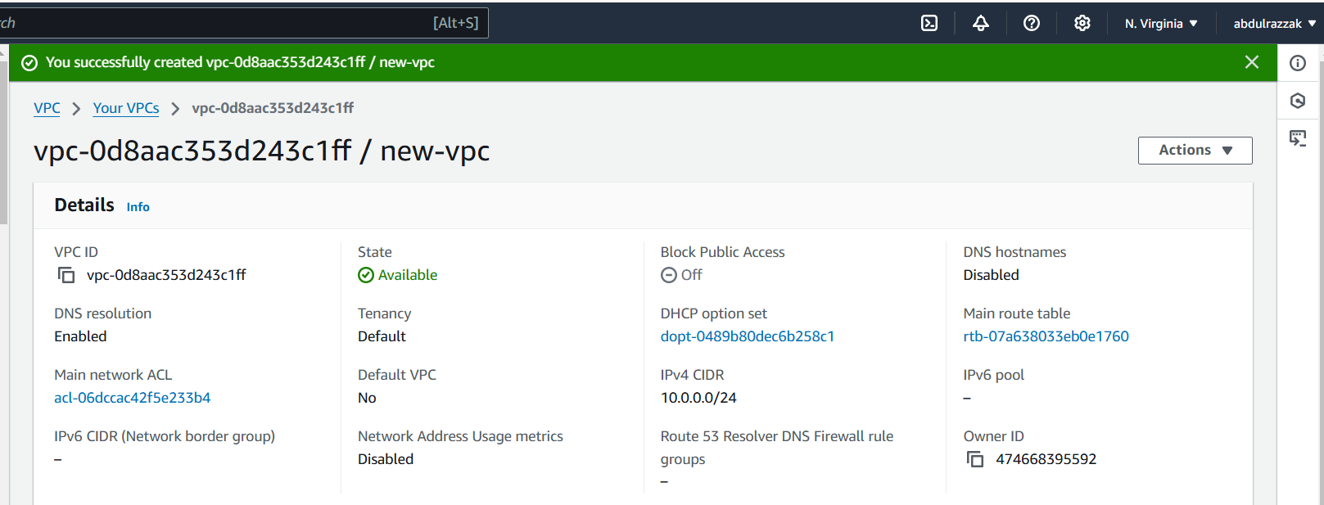

**2) Create two subnets. One Public subnet and one private subnet.**

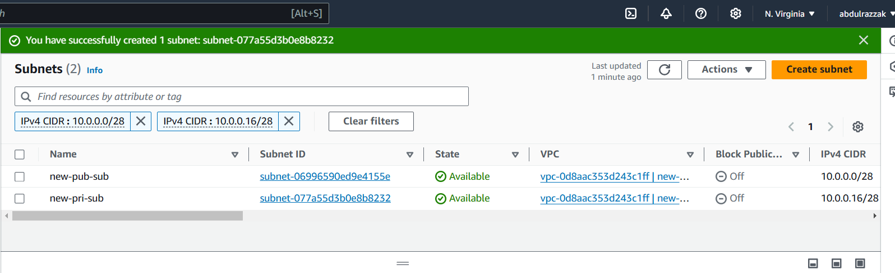

**3) Provide the IGW to the vpc.**

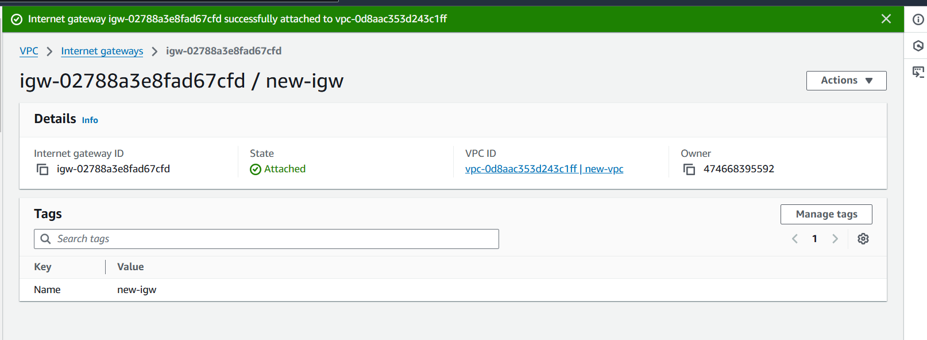

**4) Create One public RT and one private RT.**

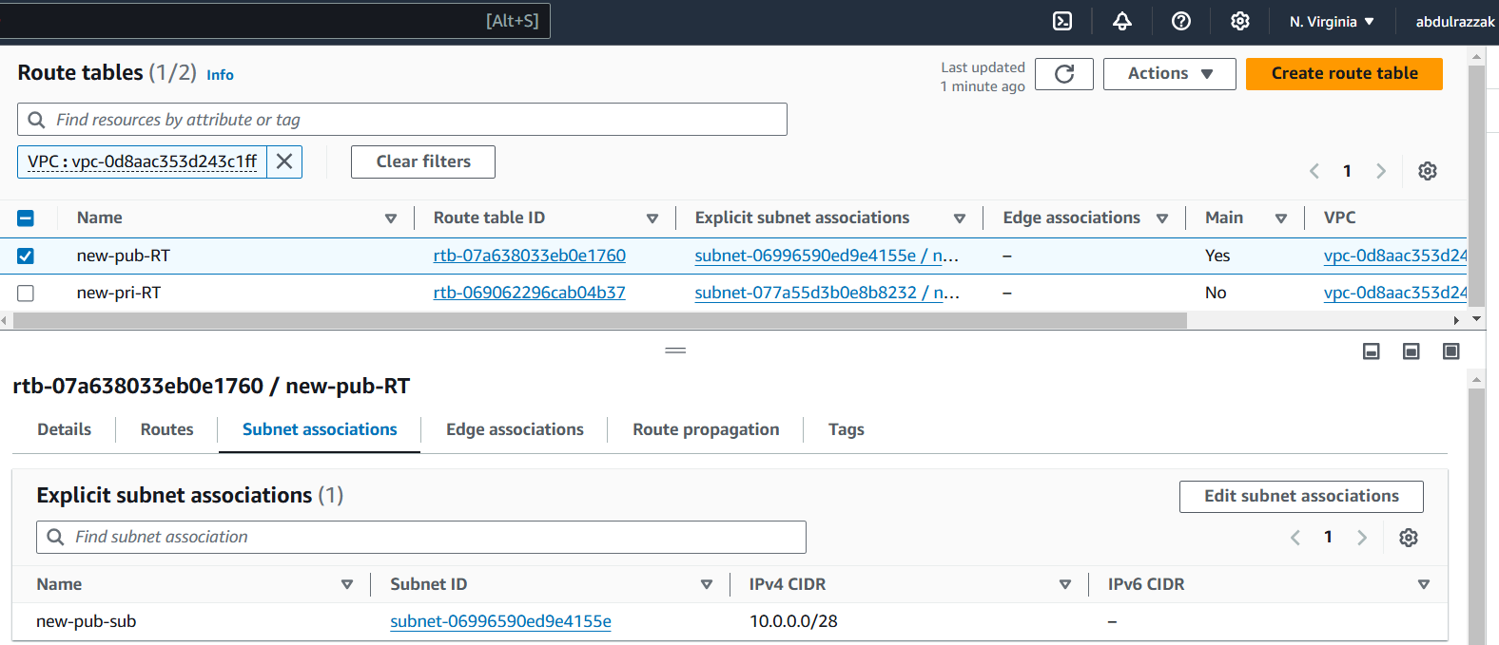

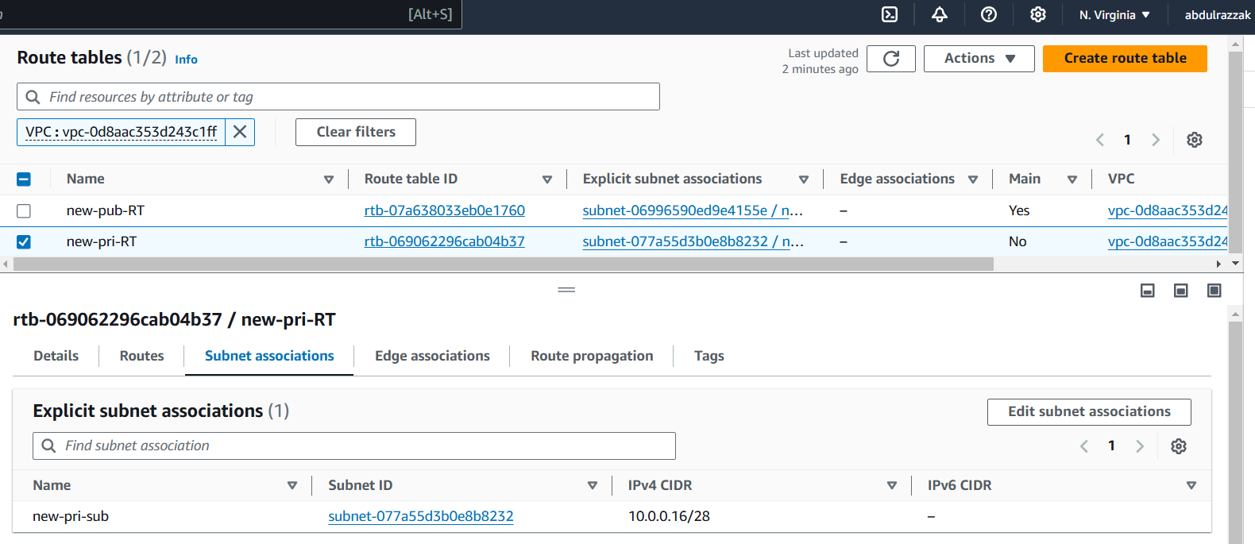

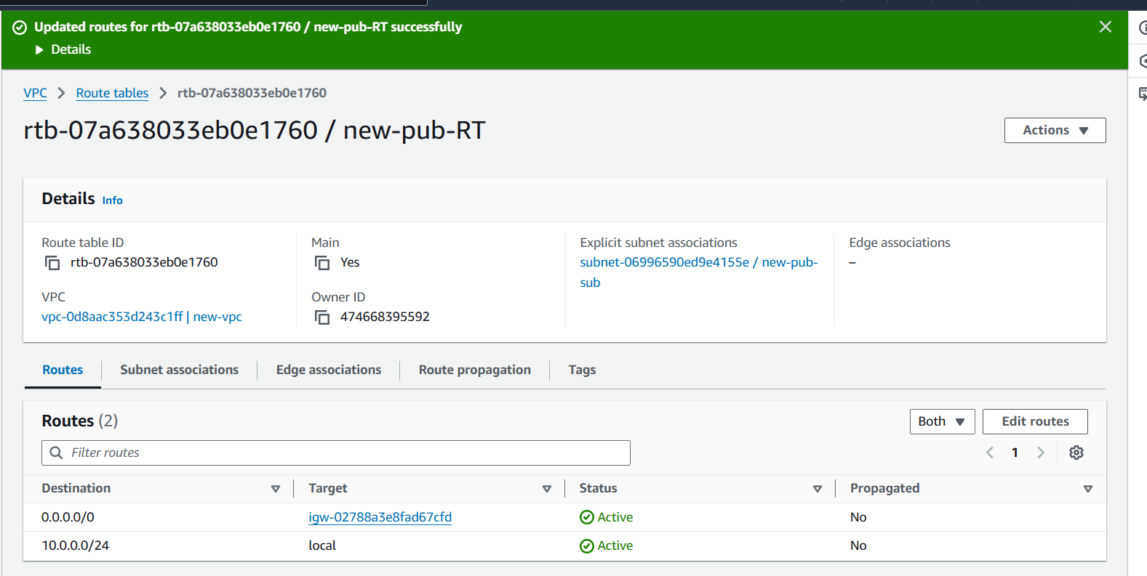

**5) Deploy NAT gateway on public subnet and attach the NAT gatewat to private subnet.**

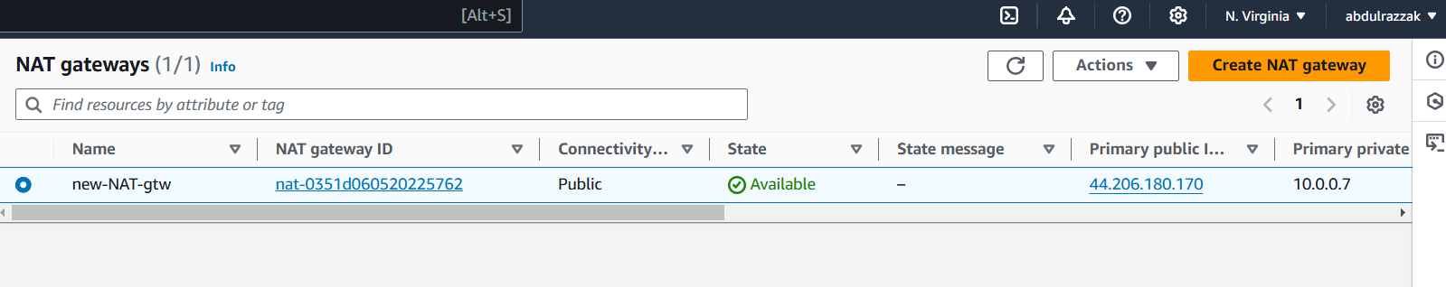

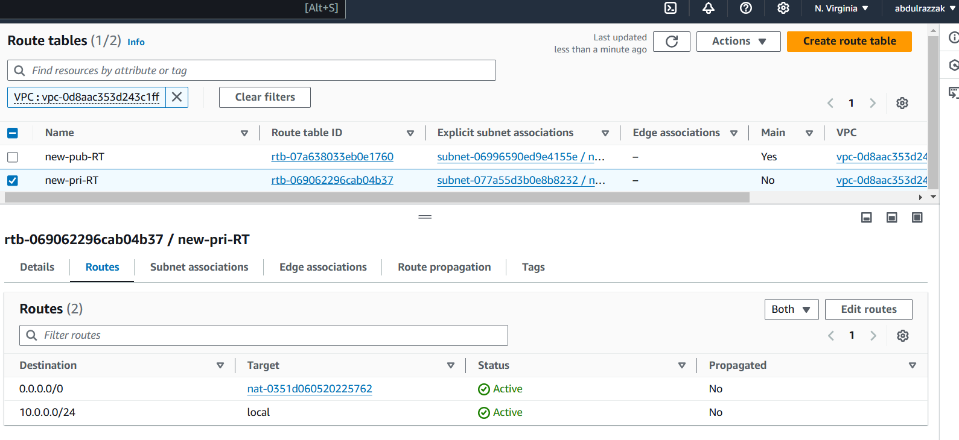

**6) Create Two instances, one in public subnet and one in private subnet.**

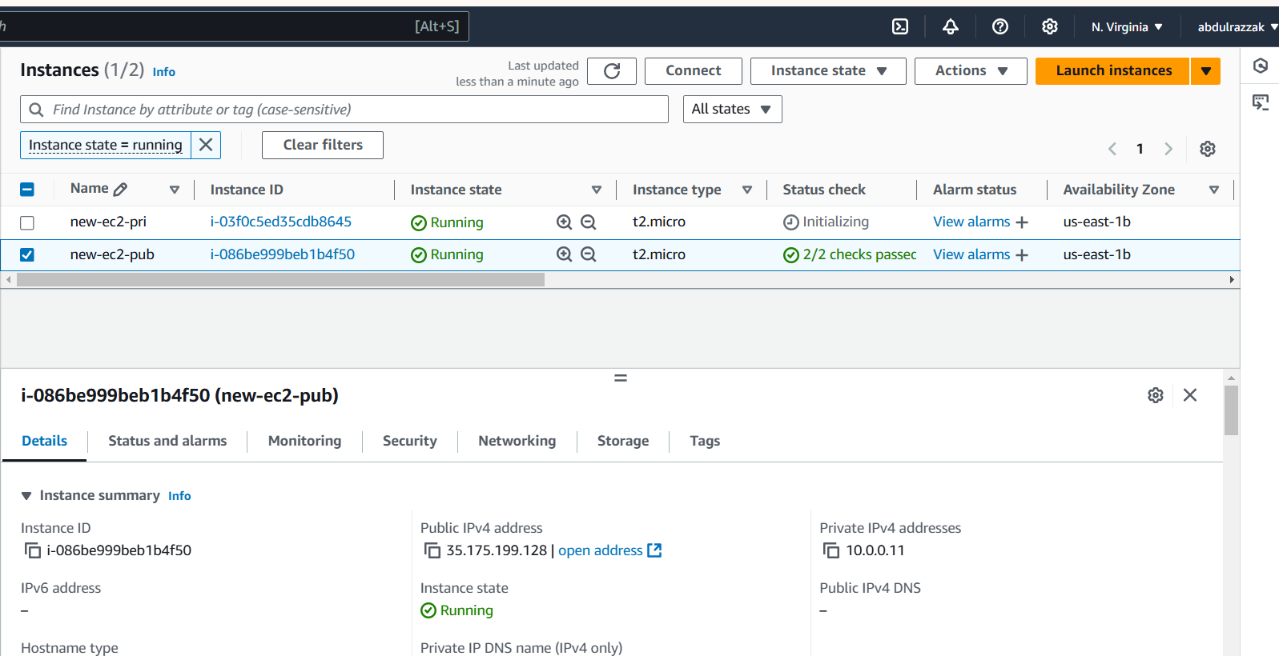

**7) Deploy Apache server on both the ec2 instances with sample index.html file.**

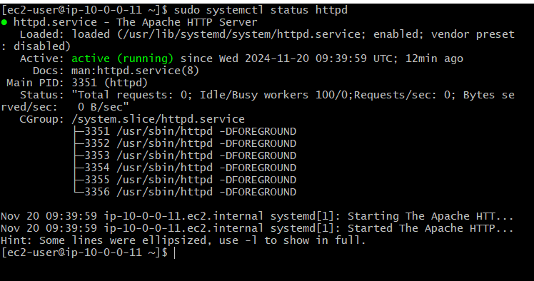



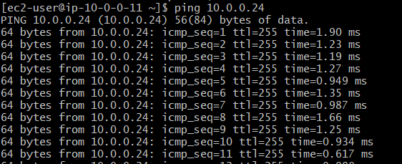

* **Connected to private Ec2 vis public instance.**
* **Ran “systemctl status httpd” to check if the httpd service is running on my private ec2 instance.**

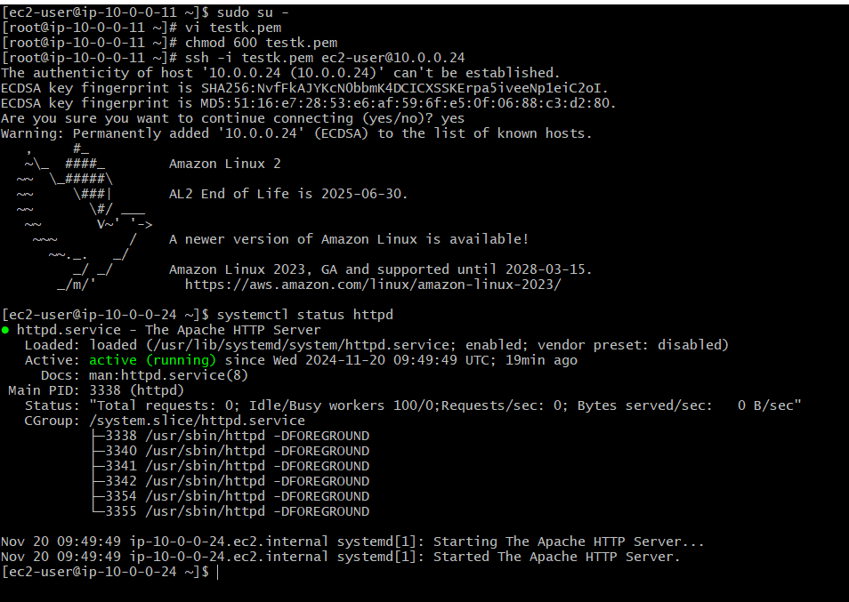

**8) Create one application load balancer and attach the load balancer to both the ec2 instances.**

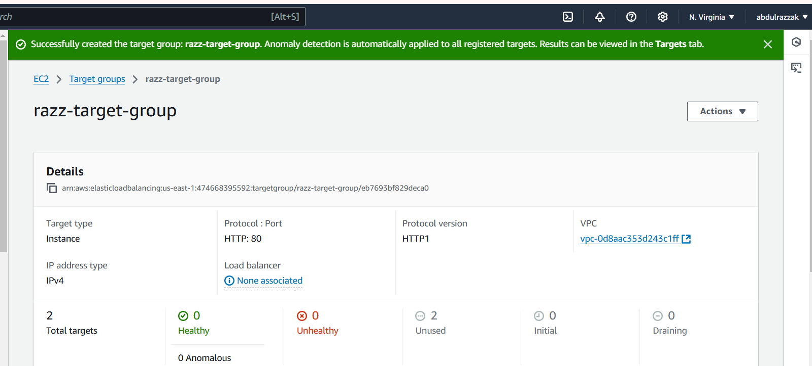

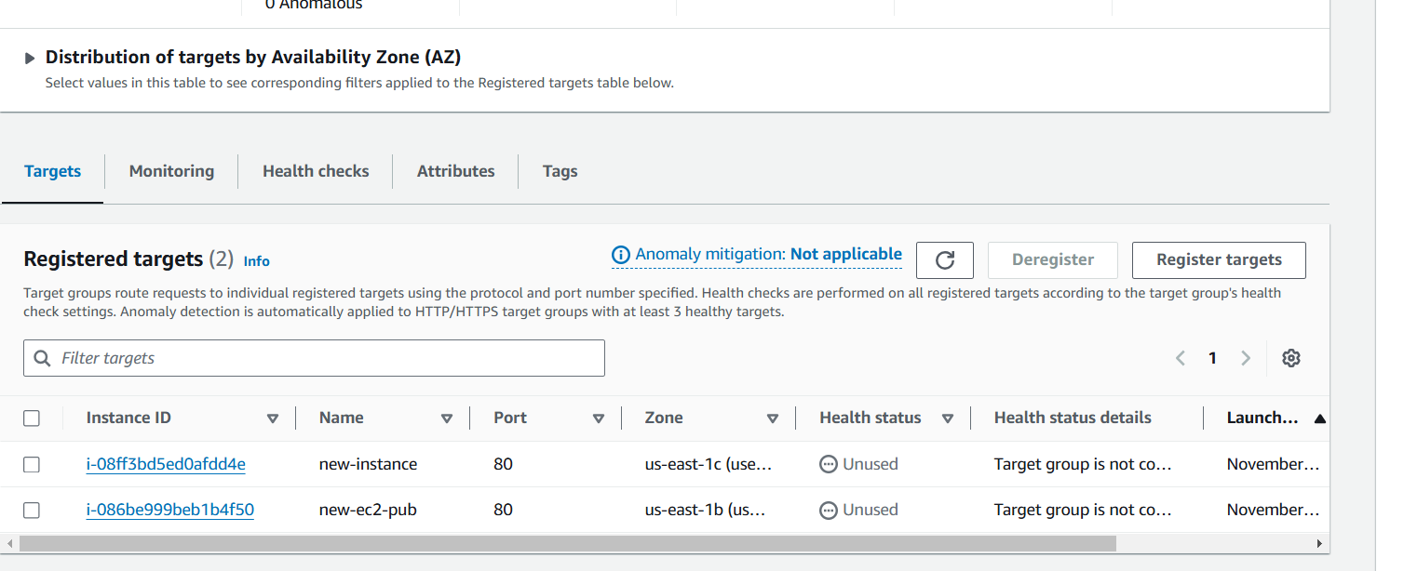

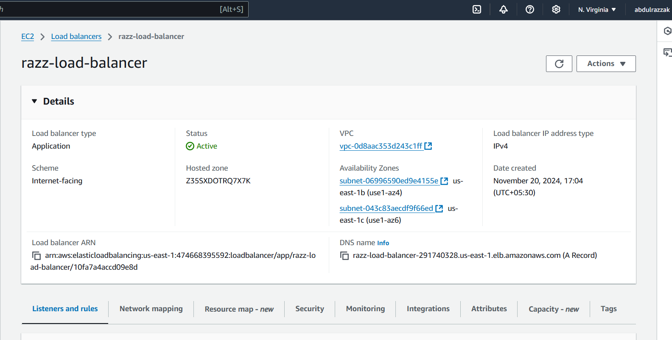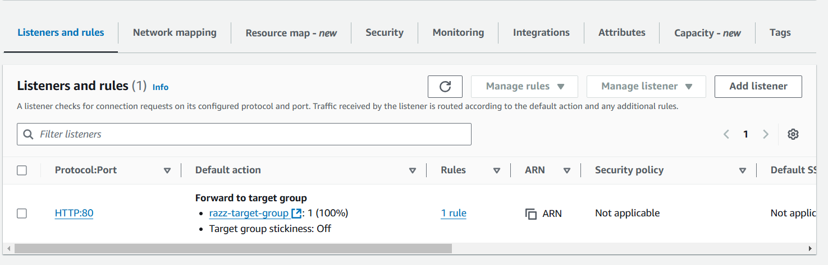

**9) Store Application load balancer logs to s3**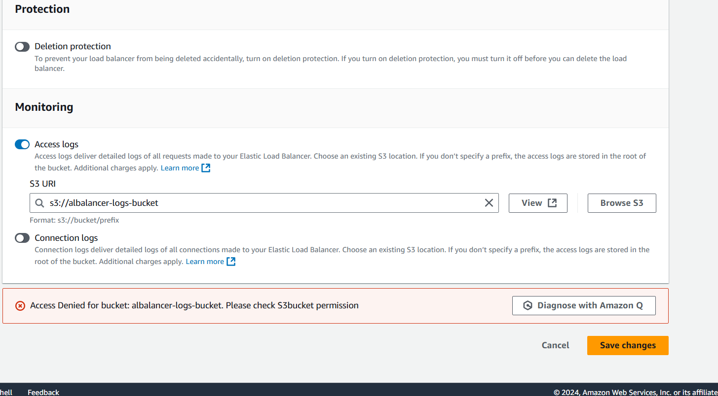

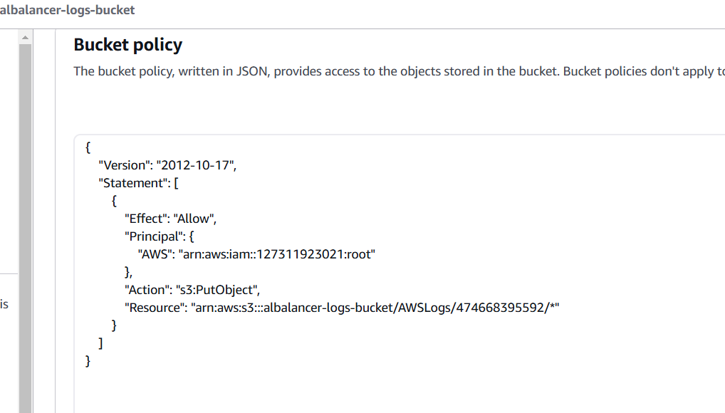

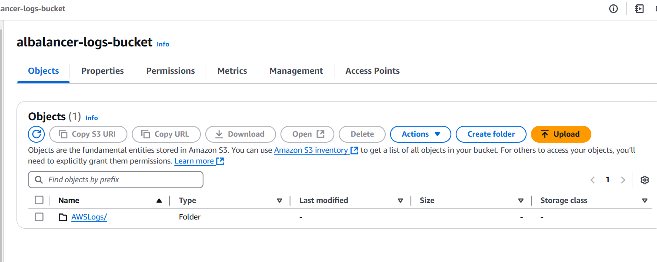

**10) Store the vpc flow logs to cloudwtach group.**

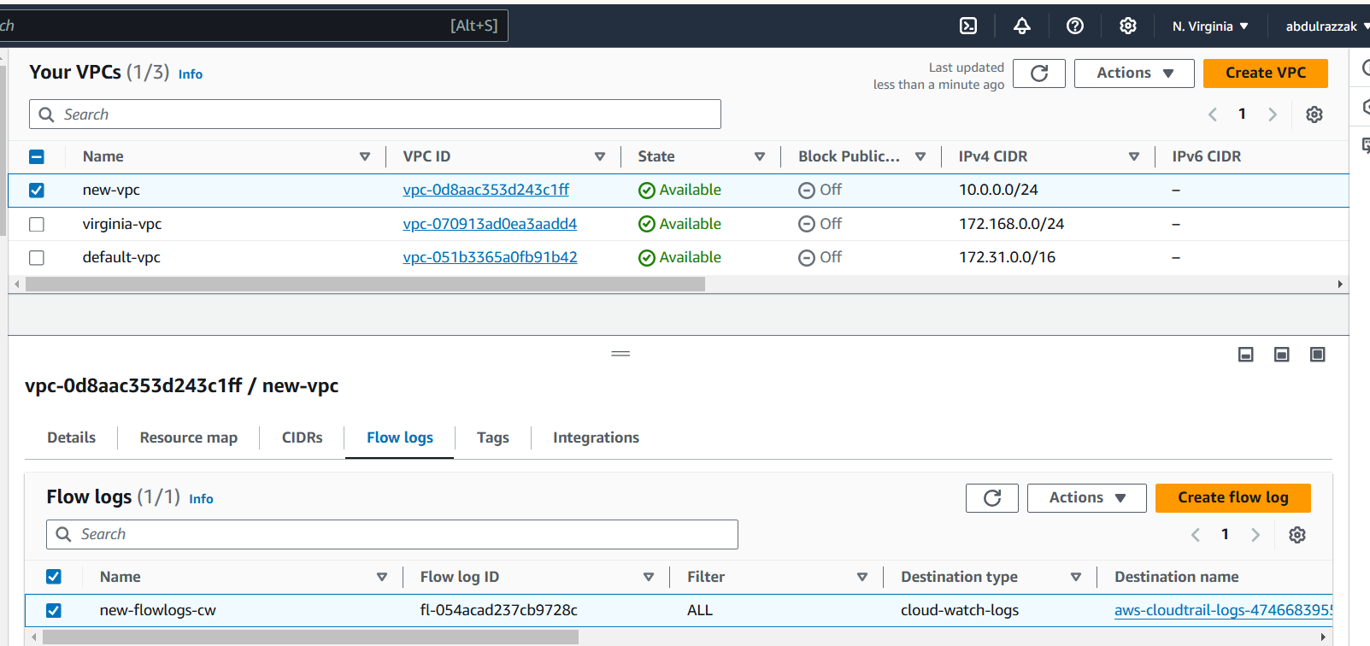

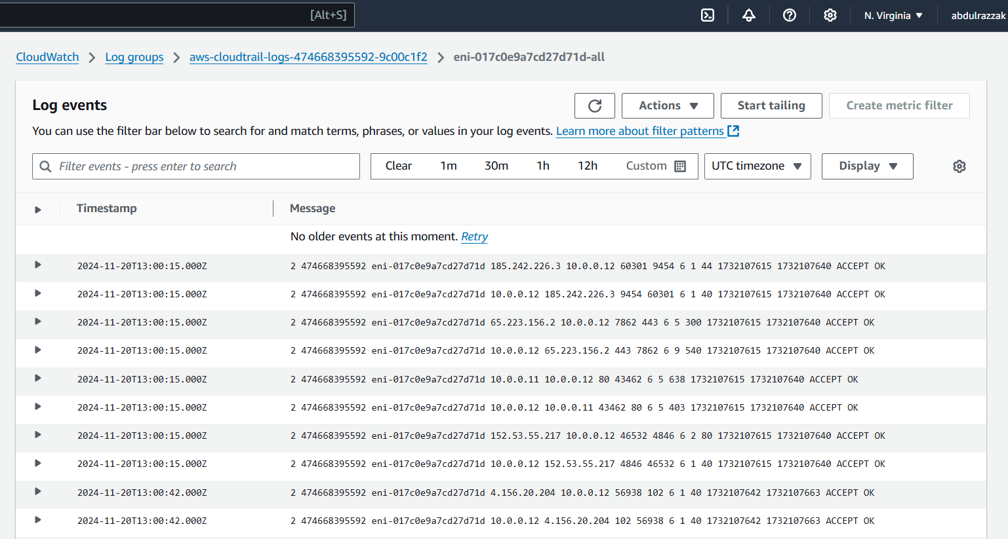

**11) Create Monitoring Dashboards to monitor cpu utilization and to monitor apache service.**

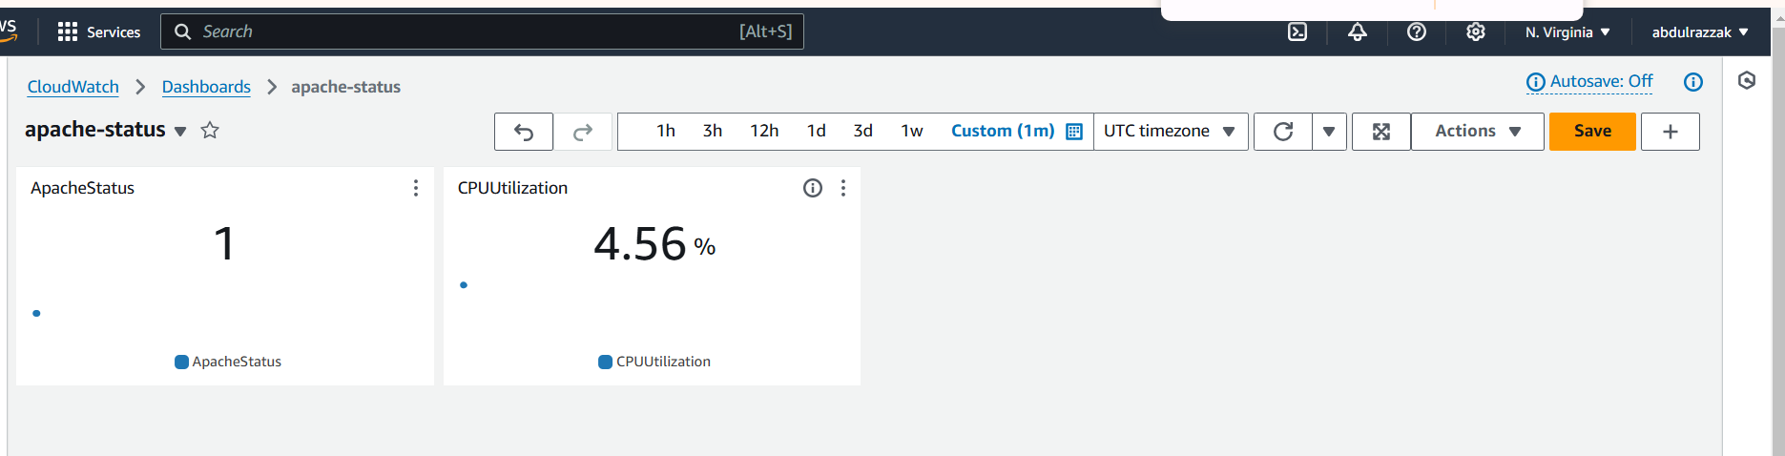

**12) CPU utilizations more than 70% then it should trigger Autoscaling and launch new instance.**

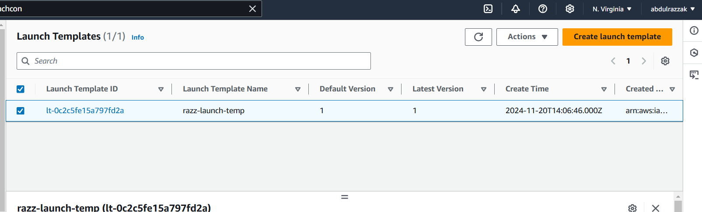

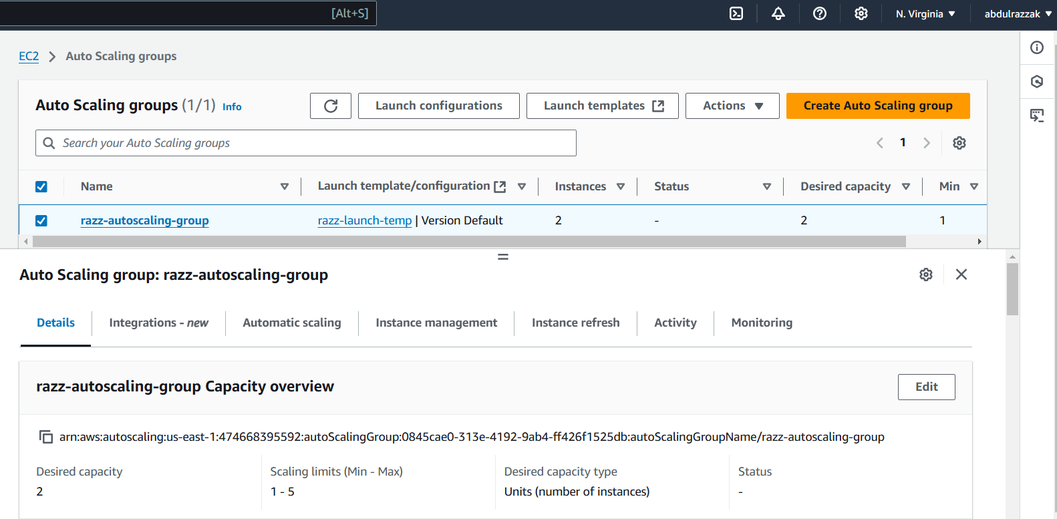

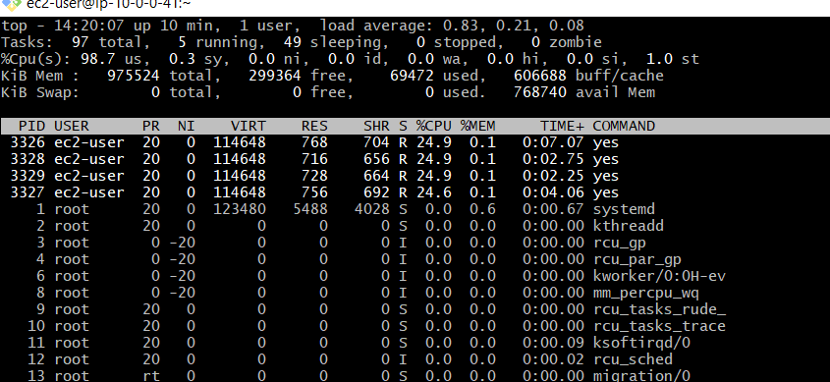

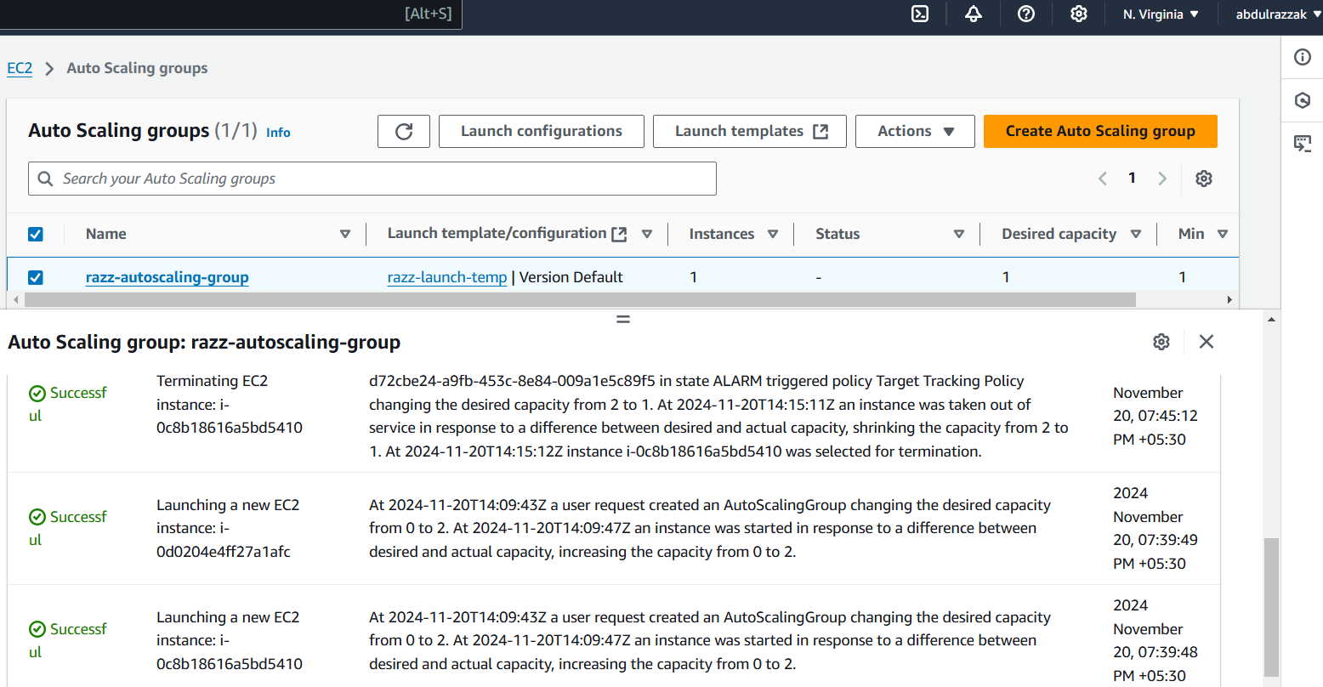

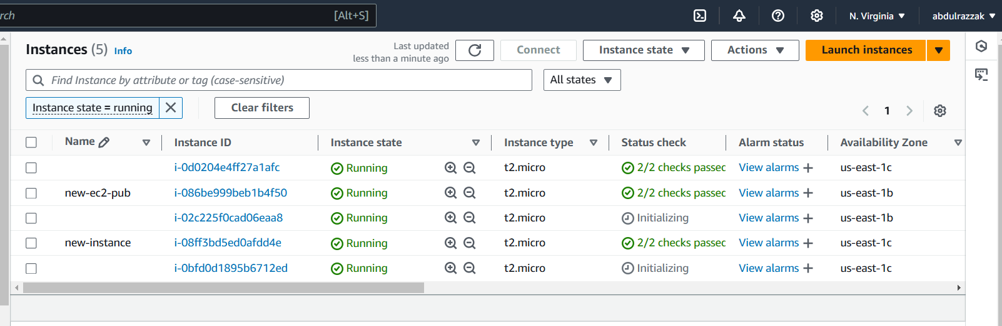

**#!/bin/bash**

**yum -y install httpd**

**touch /var/www/html/index.html**

**echo "Welcome to ASG" >> /var/www/html/index.html**

**systemctl enable httpd**

**systemctl start httpd**